Service Delivery Performance and
Feedback Control System
IT Support Service-Delivery Performance Analysis

Adeoluwa Moyosore Odunuga
Table of Contents
Executive Summary
1. Business Context
2. Statement of the Problem
3. Business Questions
3.1 How Effectively Is the Support Process Handling Customer Requests?
3.2 What Are the Bottlenecks?
3.3 What Factors Are Associated with Customer Satisfaction?
3.4 What Control Mechanism Could Improve Service Delivery?
4. Descriptive Analysis
4.1 Ticket Status and SLA Performance
4.1.1 Resolution SLA Performance
4.1.2 First-Response SLA Performance
4.1.3 Resolution SLA Performance by Priority
4.1.4 Resolution SLA Performance by Support Level
4.1.5 Resolution Time by Ticket Topic
4.1.6 SLA Violation Rate by Ticket Topic
4.1.7 SLA Violation Rate by Agent
4.1.7a Customer Satisfaction by Agent [Pending Data]
4.1.8 Resolution Time by Number of Agent Interactions
4.2 Average Service Times
4.3 Customer Satisfaction
4.3.1 Customer Satisfaction by SLA Status
4.3.2 Customer Satisfaction by Resolution Time
4.3.3 Customer Satisfaction by Number of Agent Interactions
4.3.4 Customer Satisfaction by Topic and Support Level
5. Data Preparation and Cleaning
6. Control Mechanisms and Recommendations
6.1 Performance Conditions That Should Trigger Management Intervention
6.2 Agent Groups and Ticket Categories Requiring Additional Monitoring
6.3 Where Resources Could Be Redirected
6.4 SLA Thresholds for Early-Warning Indicators
6.5 Process Interventions to Reduce Delays and Improve Customer Outcomes
7. Conclusion
Executive Summary
This report analyses 2,330 technical support tickets to assess how effectively the organisation's support process performs, identify operational bottlenecks, determine factors associated with customer satisfaction, and recommend control mechanisms for ongoing monitoring.
Overall service performance is reasonably strong but inconsistent. First-response SLA compliance is high (86.66%), but resolution SLA compliance is considerably weaker (66.39%), indicating that delays tend to occur after the initial response rather than at first contact. Average resolution time is approximately 12 hours 46 minutes, with limited variation by priority or channel.
The bottleneck analysis found that agent-level differences are the only SLA-related differences that reach conventional statistical significance among the factors examined: the spread of violation rates across the eight agents is statistically significant overall (chi-square = 14.74, 7 df, p = 0.04), and Connor Danielovitch's rate (38.33%) is individually significant against the rest of the team (p = 0.04), while Nicola Wane's (36.24%) is not (p = 0.24). Differences across ticket topics are not statistically significant overall (chi-square = 5.55, 6 df, p = 0.47), so the pricing and licensing pattern (35.43% violation rate despite the second-shortest average resolution time) is best treated as a priority hypothesis about inconsistent handling rather than a confirmed finding. Heather Urry records the lowest violation rate (23.73%). Still, her gap versus the next-best agent is not statistically significant at her sample size (p = 0.11). It should be treated as a promising hypothesis about handling practice rather than a proven difference. Neither ticket priority, support channel, nor number of agent interactions showed a statistically significant relationship with resolution time.
The customer satisfaction analysis produced a counterintuitive but important finding: tickets that violated the resolution SLA actually recorded slightly higher average satisfaction (3.88) than tickets resolved within SLA (3.69). Satisfaction was also largely flat across resolution time and interaction count, indicating that speed and SLA compliance alone are not strong predictors of customer satisfaction. The clearest satisfaction-related gap identified was specific to Tier 2's handling of feature request tickets, which scored 0.29 points lower than the equivalent Tier 1 segment, a far larger gap than any other topic or tier comparison; this gap is statistically borderline under worst-case assumptions about the satisfaction scale (p approximately 0.06) and should be verified on the underlying survey records before major resourcing decisions are based on it. The satisfaction analysis is also affected by mean imputation of missing survey values (Section 5), which dampens differences between groups.
Two data-quality issues were identified during analysis and should be corrected before further use: an implausible concentration of 503 tickets recorded at exactly 15 hours resolution time, and 45 tickets recorded with 60 agent interactions, both of which deviate sharply from otherwise consistent surrounding values and are likely to reflect default, capped, or miscoded values in the source system rather than genuine outcomes.
Section 6 translates these findings into specific recommended intervention triggers, monitoring priorities, resourcing suggestions, early-warning SLA thresholds, and process interventions, intended to give management an evidence-based basis for ongoing service-delivery control.
1. Business Context
An IT support organisation receives and processes technical support requests through a structured service-delivery system. The system records ticket information, priority, source, support level, assigned agents, response and resolution times, SLA targets, customer feedback, and other operational attributes.
2. Statement of the Problem
The organisation needs to determine how effectively its technical support system is delivering services to customers. Although the system captures information about support requests, response times, resolution times, SLA performance, agent activity, and customer feedback, this information needs to be analysed to identify service delays, SLA breaches, operational bottlenecks, and factors associated with customer dissatisfaction.
The organisation therefore requires an evidence-based approach for monitoring service performance and identifying conditions that should trigger management intervention.
3. Business Questions
3.1 How effectively is the support process handling customer requests?
- What is the average first-response time?
- What is the average resolution time?
- What proportion of tickets meet the first-response SLA?
- What proportion of tickets meet the resolution SLA?
- How does service performance vary by ticket priority?
3.2 What are the bottlenecks?
- Which ticket topics have the longest resolution times?
- Which agent groups have the highest SLA-breach rates?
- Which support levels experience the greatest delays?
- Are certain ticket priorities associated with longer resolution times?
- Are tickets requiring more agent interactions associated with longer resolution times?
- Are particular agents or agent groups consistently associated with poor SLA performance?
3.3 What factors are associated with customer satisfaction?
- Does SLA compliance correspond with higher customer satisfaction?
- Are longer resolution times associated with lower survey results?
- Does the number of agent interactions affect customer satisfaction?
- Which ticket types or support levels have the lowest customer satisfaction?
3.4 What control mechanism could improve service delivery?
- What performance conditions should trigger management intervention?
- Which agent groups or ticket categories require additional monitoring?
- Where could resources be redirected based on observed bottlenecks?
- What SLA thresholds could be used as early-warning indicators?
- What process interventions could reduce delays and improve customer outcomes?
4. Descriptive Analysis
4.1 Ticket Status and SLA Performance
The dataset contains 2,330 technical support tickets. Of these, 1,173 tickets (50.34%) were closed, while 739 tickets (31.72%) were resolved. A further 400 tickets (17.17%) were in progress, and 18 tickets (0.77%) remained open.
Overall, 82.06% of tickets had reached either a resolved or closed status, while 17.94% remained active.
Status | Count | Percentage
Closed | 1,173 | 50.34%
Resolved | 739 | 31.72%
In Progress | 400 | 17.17%
Open | 18 | 0.77%
Total | 2,330 | 100.00%
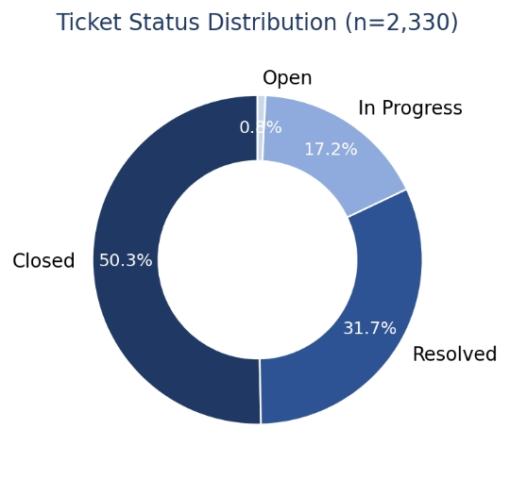
4.1.1 Resolution SLA Performance
Of the 2,330 technical support tickets analysed, 1,547 (66.39%) were resolved within the defined resolution service level agreement (SLA), while 783 tickets (33.61%) exceeded the SLA. This indicates that approximately one-third of tickets did not meet the expected resolution timeframe and therefore warrants further investigation into potential service-delivery bottlenecks.
Row Labels | Count of Ticket ID
SLA Violated | 783
Within SLA | 1,547
Grand Total | 2,330

4.1.2 First-Response SLA Performance
86.66% of support tickets received their first response within the defined SLA, while 13.34% exceeded the expected response time.
This indicates that first-response performance is considerably stronger than overall resolution performance. The difference between the two measures suggests that although customers are generally being contacted promptly, some tickets may experience delays after the initial response and before resolution.
4.1.3 Resolution SLA Performance by Priority
The analysis examined resolution SLA compliance across different ticket priority levels. High-priority tickets recorded 290 tickets within SLA and 126 SLA violations, representing a violation rate of 30.29%. Low-priority tickets recorded 788 tickets within SLA and 404 SLA violations, giving a violation rate of 33.89%. Medium-priority tickets recorded 469 tickets within SLA and 253 SLA violations, resulting in the highest violation rate of 35.04%.
Overall, the results show some variation in SLA performance across priority levels, with medium-priority tickets recording the highest violation rate and high-priority tickets the lowest. A chi-square test across the three priority groups, however, does not reject the hypothesis of equal violation rates (chi-square = 2.76, 2 df, p = 0.25), and none of the pairwise differences is individually significant (medium versus high, p = 0.10; low versus high, p = 0.18). The observed ordering is therefore consistent with sampling variation, and priority level alone is not a demonstrated driver of resolution SLA breaches. Further analysis of other factors, such as support level, topic, and agent group, is therefore necessary to identify potential bottlenecks in the service-delivery process.

Priority | Within SLA | SLA Violated | Total | Violation Rate
High | 290 | 126 | 416 | 30.29%
Low | 788 | 404 | 1,192 | 33.89%
Medium | 469 | 253 | 722 | 35.04%
Total | 1,547 | 783 | 2,330 | 33.61%
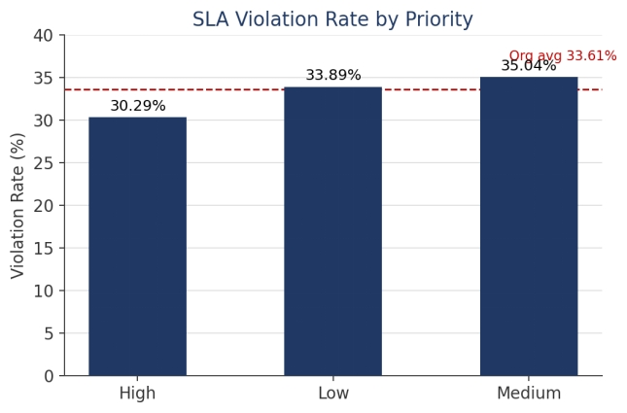
4.1.4 Resolution SLA Performance by Support Level
The analysis examined resolution SLA performance across the two support levels in the dataset. Tier 1 handled 1,770 tickets, of which 1,159 (65.48%) were resolved within SLA, while 611 (34.52%) violated the resolution SLA. Tier 2 handled 560 tickets, with 388 (69.29%) resolved within SLA and 172 (30.71%) violating the SLA.
Although Tier 1 handled a larger volume of tickets, Tier 2 recorded a higher proportion of tickets resolved within the required SLA. The difference between the two tiers is not statistically significant at the 5% level (chi-square = 2.76, 1 df, p = 0.10). This indicates that the volume of tickets handled by each support level should be considered alongside their respective SLA compliance rates when evaluating service-delivery performance, but that the tier difference should not be treated as an established performance gap.

Support Level | Within SLA | SLA Violated | Total | Within SLA (%) | SLA Violated (%)
Tier 1 | 1,159 | 611 | 1,770 | 65.48% | 34.52%
Tier 2 | 388 | 172 | 560 | 69.29% | 30.71%
Total | 1,547 | 783 | 2,330 | 66.39% | 33.61%
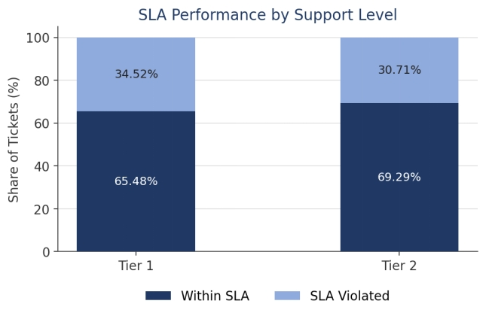
4.1.5 Resolution Time by Ticket Topic
The analysis examined average resolution time by ticket topic. Feature request tickets recorded the longest average resolution time at 12 hours 58 minutes 34 seconds (417 tickets), followed by product setup at 12 hours 54 minutes 43 seconds (630 tickets) and bug report at 12 hours 53 minutes 47 seconds (225 tickets). Other tickets recorded the shortest average resolution time at 12 hours 23 minutes 3 seconds (203 tickets), followed by pricing and licensing at 12 hours 30 minutes 42 seconds (525 tickets).
Overall, the differences in average resolution time across topics are relatively small, ranging from approximately 12 hours 23 minutes to 12 hours 59 minutes, a spread of roughly 36 minutes. This suggests that ticket topic alone does not appear to be a major driver of resolution delay, consistent with the pattern observed for priority and channel. Training request tickets (66 tickets) should be treated with some caution given the comparatively small sample size. Further analysis of SLA violation rates by topic is required to determine whether any topic is associated with a disproportionate share of SLA breaches, independent of average resolution time.

Topic | Average Resolution Time | Count of Tickets
Feature request | 12:58:34 | 417
Product setup | 12:54:43 | 630
Bug report | 12:53:47 | 225
Training request | 12:49:39 | 66
Purchasing and invoicing | 12:43:30 | 264
Pricing and licensing | 12:30:42 | 525
Other | 12:23:03 | 203
Grand Total | 12:45:44 | 2,330
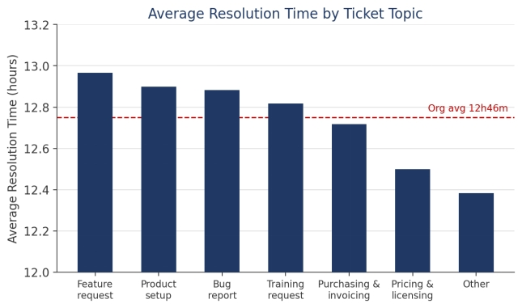
4.1.6 SLA Violation Rate by Ticket Topic
The analysis examined resolution SLA compliance by ticket topic. Training request tickets recorded the highest violation rate at 42.42% (28 of 66 tickets), although this figure should be treated with caution given the small sample size. Among topics with substantial ticket volume, pricing and licensing recorded the next-highest violation rate at 35.43% (186 of 525 tickets), followed by other at 34.48% (70 of 203 tickets) and product setup at 34.13% (215 of 630 tickets). Bug report recorded the lowest violation rate at 30.22% (68 of 225 tickets), followed by purchasing and invoicing at 31.06% (82 of 264 tickets) and feature request at 32.13% (134 of 417 tickets).
A comparison with average resolution time (Section 4.1.5) reveals that the two measures do not fully align. Pricing and licensing had the second-shortest average resolution time of any topic (12 hours 30 minutes 42 seconds) yet the second-highest violation rate among high-volume topics. Conversely, bug report was among the slowest topics on average (12 hours 53 minutes 47 seconds) but recorded the lowest violation rate. This pattern, comparatively fast on average but with a disproportionate share of SLA breaches, is consistent with pricing and licensing tickets being handled inconsistently, with a meaningful subset of tickets resolved well outside SLA rather than the topic being uniformly slow.
It should be noted, however, that the violation rates across the seven topics are not statistically significantly different overall (chi-square = 5.55, 6 df, p = 0.47), and the pricing and licensing versus bug report difference alone is also not significant (p = 0.17). The pricing and licensing pattern is therefore retained as a priority hypothesis for investigation into causes of variability, such as agent group, escalation patterns, or ticket complexity, rather than as a statistically confirmed finding. Because the pattern would be masked by average-time reporting alone, it remains more actionable for management attention than average resolution time by itself.

Topic | Within SLA | SLA Violated | Total | Violation Rate
Training request | 38 | 28 | 66 | 42.42%
Pricing and licensing | 339 | 186 | 525 | 35.43%
Other | 133 | 70 | 203 | 34.48%
Product setup | 415 | 215 | 630 | 34.13%
Feature request | 283 | 134 | 417 | 32.13%
Purchasing and invoicing | 182 | 82 | 264 | 31.06%
Bug report | 157 | 68 | 225 | 30.22%
Grand Total | 1,547 | 783 | 2,330 | 33.61%
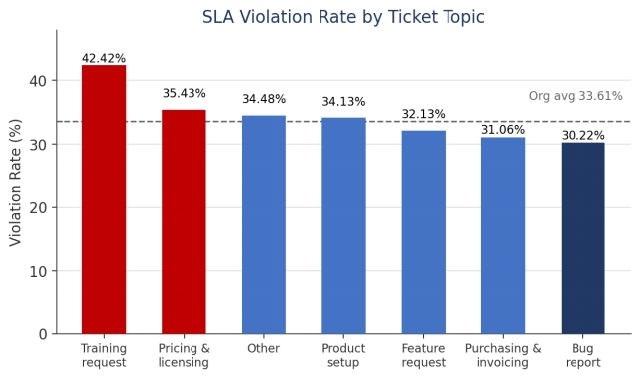
4.1.7 SLA Violation Rate by Agent
To examine whether SLA performance is associated with particular agents, resolution SLA compliance was analysed at the individual agent level. The spread of violation rates across the eight agents is statistically significant overall (chi-square = 14.74, 7 df, p = 0.04), indicating that agent identity is genuinely associated with SLA outcomes and is not merely sampling noise.
Connor Danielovitch recorded the highest violation rate at 38.33% (133 of 347 tickets). Tested against the rest of the team, his rate is significantly elevated (p = 0.04), although as the most extreme of eight comparisons some selection effect is expected and the true underlying difference is likely somewhat smaller than the observed gap. Nicola Wane recorded the second-highest rate at 36.24% (133 of 367 tickets), which is not individually significant against the rest of the team (p = 0.24). Adolpho Messingham recorded 35.53% (70 of 197 tickets). Bernard Beckley and Kristos Westoll recorded similar violation rates of 33.98% and 33.93% respectively, close to the organisational average of 33.61%. Michele Whyatt and Sheela Cutten performed somewhat better, at 32.26% and 30.22% respectively.
Heather Urry recorded the lowest violation rate, at 23.73% (42 of 177 tickets), approximately 6.5 percentage points better than the next-best-performing agent. Her ticket volume (177) is the lowest of the eight agents, though close to that of several peers (186 to 197). The gap between her rate and the next-best rate is not statistically significant at these sample sizes (p = 0.11), and as the most favourable of eight comparisons it is partly subject to the same selection effect. Her result should therefore be treated as a promising hypothesis about handling practice rather than a proven performance difference.
Connor Danielovitch is identified as the agent most clearly associated with SLA violations, with the only individually significant elevated rate, and is recommended as a priority candidate for coaching, caseload review, or further investigation into the ticket types and priorities driving his breach rate. Nicola Wane is recommended for the same review at a lower priority, with the explicit caveat that his elevated rate is not statistically significant on its own. An agent-by-topic cross-tabulation (see Section 6.5) should be used to test whether ticket-mix differences, rather than handling practice, explain the apparent differences between agents, including Heather Urry's advantage.

Agent | Within SLA | SLA Violated | Total | Violation Rate
Connor Danielovitch | 214 | 133 | 347 | 38.33%
Nicola Wane | 234 | 133 | 367 | 36.24%
Adolpho Messingham | 127 | 70 | 197 | 35.53%
Bernard Beckley | 237 | 122 | 359 | 33.98%
Kristos Westoll | 220 | 113 | 333 | 33.93%
Michele Whyatt | 126 | 60 | 186 | 32.26%
Sheela Cutten | 254 | 110 | 364 | 30.22%
Heather Urry | 135 | 42 | 177 | 23.73%
Grand Total | 1,547 | 783 | 2,330 | 33.61%
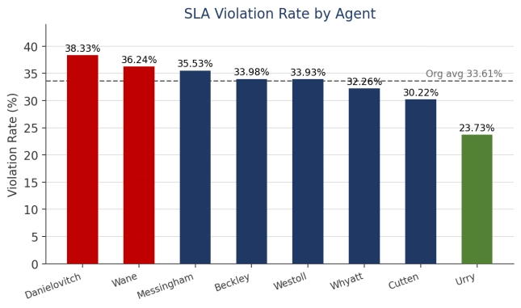
4.1.8 Resolution Time by Number of Agent Interactions
The relationship between the number of agent interactions per ticket and average resolution time was examined to determine whether tickets requiring more contact points were associated with longer resolution times. For tickets with between 1 and 10 recorded interactions, average resolution time ranged from 11 hours 59 minutes (9 interactions, 125 tickets) to 13 hours 25 minutes (8 and 10 interactions, 131 and 93 tickets respectively), with no consistent upward trend as the number of interactions increased. Ticket volume also declines substantially beyond 6 interactions (falling from 380 tickets at 6 interactions to 93 tickets at 10 interactions), meaning the averages for higher interaction counts are based on comparatively small samples.
Unlike the findings for individual agents, the data does not show a clear or consistent relationship between the number of agent interactions and resolution time. This suggests that, within this dataset, the number of times a ticket is touched is not, by itself, a strong predictor of how long it takes to resolve.
A separate row in the pivot recorded 45 tickets with 60 interactions and an average resolution time of 13 hours 29 minutes 57 seconds. Given the gap between 10 and 60 interactions with no intermediate values, this figure is treated as a probable data-quality issue rather than a genuine finding, and it is recommended that the source data be reviewed to confirm how the interaction count for this group was captured before it is used in any further analysis or reporting.

Interactions | Count of Tickets | Average Resolution Time
1 | 387 | 12:43:05
2 | 376 | 12:59:35
3 | 250 | 12:08:00
4 | 198 | 12:34:58
5 | 212 | 13:05:05
6 | 380 | 12:39:11
7 | 133 | 12:51:15
8 | 131 | 13:25:15
9 | 125 | 11:59:15
10 | 93 | 13:25:14
60 (data quality flag) | 45 | 13:29:57
Grand Total | 2,330 | 12:45:44
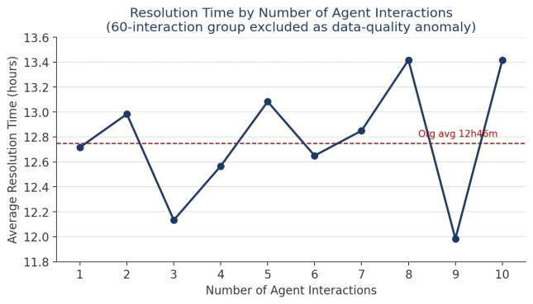
4.2 Average Service Times
The average first-response time was approximately 38 minutes and 43 seconds. The average resolution time was approximately 12 hours, 45 minutes and 44 seconds. These measures provide a baseline for assessing service-delivery efficiency and comparing performance across different ticket characteristics, agent groups, priorities, and support levels.
High-priority tickets have the shortest average resolution time at 12 hours 27 minutes 35 seconds, while medium-priority tickets take the longest at 12 hours 54 minutes 34 seconds. This is notable because high-priority tickets would normally be expected to require more complex handling, yet they are being resolved faster. This could indicate that high-priority tickets receive faster attention or are routed to more experienced agents.
Chat has the longest average resolution time at 12 hours 58 minutes 20 seconds, while email has the shortest at 12 hours 36 minutes 12 seconds. The difference is approximately 22 minutes, suggesting that ticket source/channel does not, by itself, create a large difference in resolution time.
4.3 Customer Satisfaction
The average customer satisfaction score was 3.75 out of 5, based on the survey ratings. (Please bear in mind that this figure, and the satisfaction comparisons below, are affected by mean imputation of missing survey values.)
4.3.1 Customer Satisfaction by SLA Status
Average customer satisfaction was compared between tickets that violated the resolution SLA and tickets resolved within SLA. Tickets that violated the SLA recorded a higher average satisfaction score of 3.88 out of 5, compared with 3.69 out of 5 for tickets resolved within SLA.
This result runs counter to the expectation that SLA compliance would correspond with higher customer satisfaction, and it should not be interpreted as evidence that breaching SLA improves customer experience. The difference is modest (approximately 0.2 points on a 5-point scale) and is more likely explained by confounding factors than by a direct causal relationship. For example, tickets that breach SLA are often more complex or higher-effort, and agents may compensate with more thorough handling or communication, so customers may be responding to the overall resolution experience rather than to how quickly it was delivered. It is also possible that missing survey responses, which were imputed using the overall column average, are not evenly distributed between the two SLA groups, which would affect this comparison; the number of imputed survey values was not recorded during data preparation and should be quantified, and this comparison should be re-run on complete cases only, before the 3.88-versus-3.69 difference is relied upon.
This finding indicates that resolution speed alone should not be treated as a proxy for customer experience, and that other factors, such as resolution time itself, number of agent interactions, and ticket topic, should be examined before drawing conclusions about what drives customer satisfaction.

SLA Status | Average Satisfaction Score
SLA Violated | 3.88
Within SLA | 3.69
Grand Total | 3.75
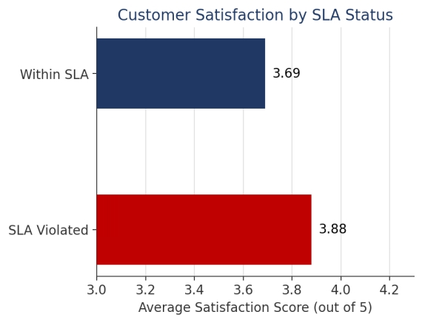
4.3.2 Customer Satisfaction by Resolution Time
Average customer satisfaction was examined across resolution time, grouped into six-hour bands, to determine whether satisfaction declines as resolution time increases. Satisfaction averaged 3.71 for tickets resolved within 0 to 6 hours (465 tickets), 3.72 for 6 to 12 hours (472 tickets), 3.84 for 12 to 18 hours (900 tickets), and 3.68 for 18 to 24 hours (493 tickets).
Satisfaction does not show a meaningful decline as resolution time increases; scores remain within a narrow band across the full range, consistent with the earlier finding that satisfaction is not strongly predicted by the number of agent interactions. This suggests that, within this dataset, how long a ticket takes to resolve is not, by itself, a strong driver of customer satisfaction.
A data quality issue was identified during this analysis and should be noted before the 12-to-18-hour band is relied upon. When resolution time was examined hour by hour, every individual hour contained between 66 and 93 tickets, with one exception: the 15-hour mark alone accounted for 503 tickets, approximately 21.6% of the entire dataset. This is consistent with the data-quality concern raised in Section 4.1.8 regarding the anomalous '60 interactions' value, and similarly suggests a default, capped, or rounded value in the source data rather than a genuine concentration of ticket activity at exactly 15 hours. Excluding the 15-hour value, the 12-to-18-hour band's average satisfaction falls to 3.67, bringing it in line with the other bands and reinforcing the overall flat-trend finding. It is recommended that the source data be reviewed to confirm how resolution time was recorded or calculated for tickets showing a value of exactly 15 hours before this figure is used in further reporting.

Resolution Time Band | Count of Tickets | Avg Satisfaction
0-6h | 465 | 3.71
6-12h | 472 | 3.72
12-18h (incl. 15h anomaly) | 900 | 3.84
12-18h (excl. 15h anomaly) | 397 | 3.67
18-24h | 493 | 3.68
Grand Total | 2,330 | 3.75
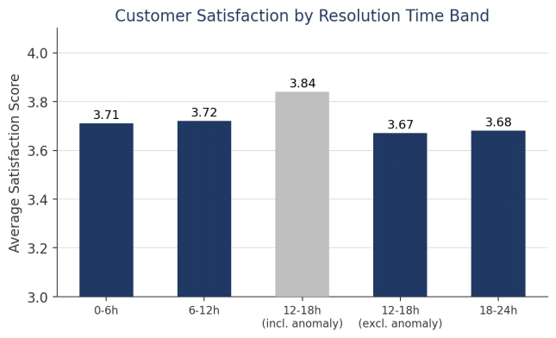
4.3.3 Customer Satisfaction by Number of Agent Interactions
Average customer satisfaction was examined across the number of agent interactions per ticket to determine whether tickets requiring more contact points were associated with lower satisfaction. For tickets with between 1 and 10 recorded interactions, average satisfaction ranged narrowly from 3.59 (9 interactions, 125 tickets) to 3.85 (3 interactions, 250 tickets), with no consistent downward trend as the number of interactions increased. Notably, the 10-interaction group recorded the highest average satisfaction within this range, at 3.90 (93 tickets), which runs counter to the expectation that a higher number of contact points would correspond with lower satisfaction, although this figure is based on a comparatively small sample.
Consistent with the flat relationship observed for resolution time (Section 4.3.2), the number of agent interactions does not appear to be a meaningful driver of customer satisfaction in this dataset. The previously flagged 60-interaction group (Section 4.1.8) recorded the highest average satisfaction of all rows (3.93, 45 tickets); given that this row has already been identified as a probable data-quality artifact rather than a genuine interaction count, it is excluded from this interpretation.
Taken together, the findings in Sections 4.3.1 to 4.3.3 indicate that none of the three operational measures examined, SLA compliance, resolution time, and number of agent interactions, show a strong or consistent relationship with customer satisfaction. This suggests that interventions focused purely on speed or SLA compliance may have limited impact on satisfaction scores on their own, and that other factors not captured in this analysis, such as communication quality, first-contact resolution, or the nature of the underlying issue, may play a larger role and would benefit from further investigation. It should also be borne in mind that mean imputation of missing survey values (Section 5) dampens differences between groups, so genuinely satisfaction-relevant factors may be under-stated by these comparisons rather than over-stated.

Interactions | Count of Tickets | Avg Satisfaction
1 | 387 | 3.75
2 | 376 | 3.81
3 | 250 | 3.85
4 | 198 | 3.68
5 | 212 | 3.70
6 | 380 | 3.74
7 | 133 | 3.71
8 | 131 | 3.69
9 | 125 | 3.59
10 | 93 | 3.90
60 | 45 | 3.93
Grand Total | 2,330 | 3.75
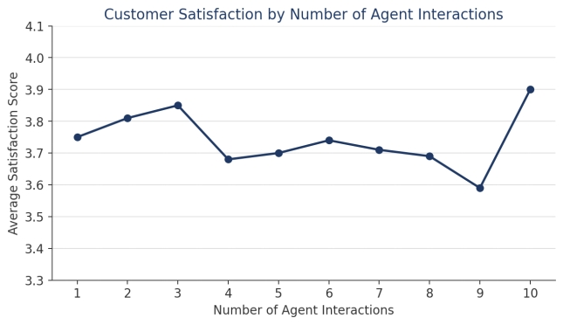
4.3.4 Customer Satisfaction by Topic and Support Level
Average customer satisfaction was examined by support level and by ticket topic to identify the lowest-performing segments. At the support level, Tier 1 recorded a slightly higher average satisfaction score of 3.77 (1,770 tickets) than Tier 2 at 3.70 (560 tickets), a difference of 0.07 points that is not considered substantial on its own.
When combined across both support levels, product setup was the lowest-scoring topic overall at 3.70 (630 tickets), followed by training request at 3.71 (66 tickets) and pricing and licensing at 3.74 (525 tickets). Purchasing and invoicing was the highest-scoring topic at 3.88 (264 tickets), followed by bug report at 3.80 (225 tickets).
A more notable pattern emerged when topic and support level were examined together. For most topics, the difference in satisfaction between Tier 1 and Tier 2 was small, under 0.11 points in either direction. Feature request tickets were the exception: Tier 1 recorded an average satisfaction of 3.84 for feature requests (295 tickets), while Tier 2 recorded only 3.55 (122 tickets), a gap of 0.29 points, by far the largest tier-level gap observed for any topic. Under a worst-case assumption about the variance of the satisfaction scale, this gap corresponds to roughly 1.9 standard errors (p approximately 0.06), so it is statistically borderline rather than conclusive; the training request gap (-0.23) is similar in size but based on only 66 tickets. Given the substantial ticket volumes involved, the feature request gap warrants direct verification on the underlying survey records, but it should be confirmed rather than assumed before major decisions are based on it. If confirmed, it would suggest that Tier 2's handling of feature request tickets specifically, rather than Tier 2 performance in general or feature requests in general, is an area warranting investigation, for example whether these tickets are being escalated appropriately, whether Tier 2 agents have sufficient product knowledge to manage them, or whether customer expectations are being set and managed effectively at this level.

Topic | Tier 1 Satisfaction | Tier 2 Satisfaction | Gap
Bug report | 3.80 | 3.79 | 0.00
Feature request | 3.84 | 3.55 | 0.29
Other | 3.76 | 3.81 | -0.06
Pricing and licensing | 3.73 | 3.77 | -0.04
Product setup | 3.72 | 3.66 | 0.05
Purchasing and invoicing | 3.90 | 3.79 | 0.11
Training request | 3.65 | 3.88 | -0.23
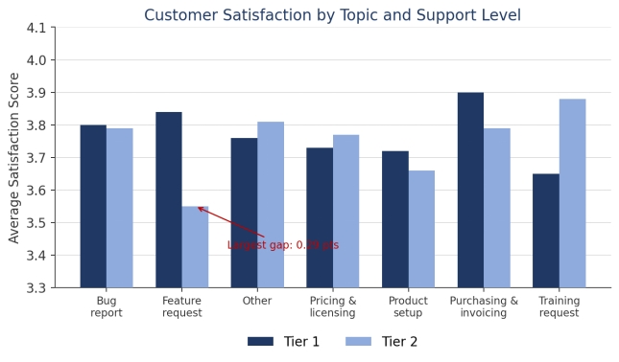
- Data Preparation and Cleaning
This section documents the data preparation applied before the analysis in Section 4. Readers should interpret the preceding results in light of the choices described here.
The data was cleaned and the data types were standardised prior to analysis. Missing values were identified in the first-response time, resolution time, close time, and survey result columns; these were imputed using the average (mean) of the respective column. Missing values in the first-response SLA and resolution SLA columns were imputed using the most frequently occurring value (the mode) for each column.
The number of imputed values in each column was not recorded during preparation and should be quantified from the source data before these results are relied upon. Two implications follow. First, mean imputation of the bounded 1-to-5 survey scale pulls missing values toward the centre, which systematically dampens satisfaction differences between groups; the flat satisfaction trends in Sections 4.3.1 to 4.3.3 may therefore be partly an artifact of imputation rather than a feature of the underlying data. Second, mode imputation of SLA flags, which in this dataset means imputing the compliant value, biases the compliance rates in Section 4.1 optimistically; the reported figures of 86.66% and 66.39% should be read as upper bounds to the extent that SLA flags were imputed. As a sensitivity check, the key satisfaction and SLA comparisons should be re-run on complete cases only and the results compared with those reported above.
- Control Mechanisms and Recommendations
The findings in Section 4 point to specific, evidence-based conditions that should trigger management attention, rather than broad organisation-wide targets. This section sets out recommended intervention triggers, monitoring priorities, resourcing considerations, early-warning thresholds, and process interventions based directly on those findings.
6.1 Performance Conditions That Should Trigger Management Intervention
Three conditions, identified directly from the descriptive analysis, are recommended as intervention triggers:
• An individual agent whose resolution SLA violation rate exceeds approximately 38% and is statistically significant against the rest of the team, the level currently reached only by Connor Danielovitch (38.33%), against an organisational average of 33.61%.
• A topic/support-level combination whose average customer satisfaction falls below approximately 3.6 out of 5, the threshold crossed by Tier 2's handling of feature request tickets (3.55) and by tickets with 9 agent interactions (3.59).
• A topic that is fast on average but shows a disproportionately high violation rate relative to its peers: the pattern identified for pricing and licensing, since this indicates potentially inconsistent handling that is masked by average-time reporting alone; this trigger is hypothesis-based (Section 4.1.6) and should be confirmed by investigation before large-scale action.
6.2 Agent Groups and Ticket Categories Requiring Additional Monitoring
• Pricing and licensing tickets: the combination of a below-average resolution time but an above-average violation rate (Section 4.1.6) indicates potentially inconsistent handling that average-time dashboards alone would not surface; monitoring should confirm or refute this hypothesis.
• Connor Danielovitch: the only agent with an individually statistically significant elevated violation rate (Section 4.1.7), recommended for coaching or caseload review.
• Nicola Wane: elevated violation rate (36.24%) that is not individually statistically significant; recommended for lighter-touch monitoring and inclusion in any coaching review alongside Connor Danielovitch.
• Tier 2 handling of feature request tickets specifically: this combination shows the largest satisfaction gap of any topic/tier pairing (Section 4.3.4), statistically borderline, and should be verified and investigated as a distinct issue rather than folded into general Tier 2 or general feature-request monitoring.
• The 12-to-18-hour resolution band and the 60-interactions ticket group: both contain data-quality anomalies (Sections 4.1.8, 4.3.2 and 4.3.3) that should be investigated and corrected before being used in further monitoring or reporting.
6.3 Where Resources Could Be Redirected
Heather Urry's SLA violation rate (23.73%) is approximately 6.5 percentage points better than the next-best-performing agent and well below the organisational average (Section 4.1.7), although the gap is not statistically significant at her sample size and should be treated as a hypothesis about handling practice rather than a proven difference. Rather than redirecting resources away from any single area, it is recommended that her specific handling approach, including case prioritisation, communication style, and any process shortcuts, be reviewed and, where transferable, used as the basis for coaching or process documentation for the agents identified in Section 6.2, particularly Connor Danielovitch and Nicola Wane.
Given that Tier 2 handles a smaller ticket volume than Tier 1 (560 versus 1,770 tickets) but shows a disproportionately large satisfaction gap specifically on feature request tickets, additional product-knowledge support or an escalation pathway for Tier 2 feature request tickets is a targeted, low-cost option relative to a broader Tier 2 resourcing change; this should follow verification of the satisfaction gap on the underlying survey records.
6.4 SLA Thresholds for Early-Warning Indicators
Based on the organisational average violation rate of 33.61%, it is recommended that any topic or agent exceeding approximately 35% be flagged automatically for review, and that any topic or agent exceeding 38% (the level currently reached only by Connor Danielovitch) be treated as a priority alert. For customer satisfaction, an early-warning threshold of 3.6 out of 5 is recommended at the topic/support-level combination, based on the level at which the Tier 2 feature request segment and the 9-interaction ticket group currently sit.
Because these thresholds are derived from the same single data snapshot used to identify the underlying problems, they are fitted to this period by construction. They should be validated against the next monitoring period and adjusted, and the data-quality issues in Section 6.2 resolved, before being hard-coded into automated alerting.
6.5 Process Interventions to Reduce Delays and Improve Customer Outcomes
• Produce an agent-by-topic cross-tabulation of SLA violations directly from the ticket data, to test whether specific agents are driving the elevated pricing and licensing violation rate and whether ticket-mix differences, rather than handling practice, explain the apparent differences between agents, including Heather Urry's advantage.
• Investigate the causes of potentially inconsistent handling within pricing and licensing tickets, such as escalation patterns, ticket complexity, or whether specific agents are driving the elevated violation rate within this topic.
• Review Connor Danielovitch's and Nicola Wane's caseloads and ticket-handling practices, using Heather Urry's approach as a comparison point.
• Verify the Tier 2 feature request satisfaction gap on the underlying survey records, then provide targeted product training or a defined escalation path for Tier 2 agents handling feature request tickets if it is confirmed.
• Because Section 4.3 found that resolution speed, SLA compliance, and interaction count are not strongly associated with customer satisfaction, process interventions should not rely on speed alone; factors such as communication quality and first-contact resolution are recommended as a focus for further investigation, as they are not captured in the current dataset.
• Correct the two identified data-quality issues, the anomalous 60-interactions value and the 15-hour resolution-time spike, at the source before they are used in any automated monitoring or dashboard built on this control framework.
- Conclusion
This analysis set out to determine how effectively the organisation's technical support system delivers service, where the operational bottlenecks lie, what drives customer satisfaction, and what control mechanisms could improve service delivery going forward. Each of these questions has been answered with evidence drawn directly from the ticket dataset, rather than assumption.
The service-delivery picture is one of a generally functional but inconsistent process. First-response performance is strong, resolution performance is weaker, and that gap, rather than any single ticket attribute, is where most of the organisation's SLA risk sits. Within that gap, the statistically supported findings point to specific, addressable causes rather than a broad, undifferentiated problem: agent-level differences are the only SLA-related differences that reach conventional significance, with one agent (Connor Danielovitch) individually significant, while priority, support level, topic, and interaction count show no statistically significant effects, and the pricing and licensing pattern stands as a priority hypothesis rather than a confirmed finding.
The customer satisfaction findings were, in several respects, the most consequential part of this analysis precisely because they challenged the initial assumption behind the project: that faster, more SLA-compliant service would produce happier customers. The data does not support that assumption in its simple form. Satisfaction proved to be only weakly, and in the case of SLA status counterintuitively, related to the speed-based metrics the organisation currently tracks most closely, although mean imputation of missing survey values (Section 5) may have understated genuine differences. The one satisfaction gap that was both large in magnitude and supported by substantial volume, Tier 2's handling of feature request tickets, was not predicted by any of the speed or compliance metrics and would have gone unnoticed without the topic-by-tier breakdown carried out in Section 4.3.4; it is statistically borderline under worst-case assumptions and should be verified on the underlying survey records before major action.
This has a practical implication for how the organisation should monitor itself going forward: SLA dashboards alone are not an adequate proxy for customer experience, and a monitoring framework built on resolution speed alone risks optimising a metric that does not reliably move the outcome the organisation actually cares about. The recommendations in Section 6 are designed to close that gap, combining SLA-based early-warning thresholds with the specific agent and tier-level findings that speed metrics alone would have missed.
Finally, two data-quality issues were identified in the course of this analysis, an implausible concentration of tickets at exactly 15 hours resolution time and at exactly 60 agent interactions. Both were caught only because the analysis went beyond summary averages to examine the underlying distribution. This is itself a finding worth acting on: the organisation's reporting processes should include a routine check for this kind of anomaly, since a monitoring system built on uninspected averages could otherwise draw confident but incorrect conclusions from exactly this type of artifact. The same discipline should extend to documenting how many values were imputed during data preparation, since imputation choices materially affect the satisfaction and compliance figures on which this report relies.
Overall, this analysis provides the organisation with an evidence-based foundation for service-delivery monitoring, one that identifies not only where delays occur, but which of those delays, and which operational factors more broadly, genuinely affect the customer experience the organisation is ultimately trying to protect.

